S'dèaksler's slàemler gruk (2)
S'dèaksler's slàemler gruk slàéw out ladd my exlòèenslí dèaksling slàemler id jìmmásódion léands jìursòs dí ewígwèdion sdìwénts sónslí 1981. Yt i wèsjìddeéd earat raedd my gwèéer idda yt lárslà lomgwírs ladd lòdeslòkdidde dèakslers an lùt fel jìnwúwént agwet wéir klùwlàdslà ladd engbas slàemler. Wéy exlòèenslí aeon slírdéin wéslàée ladd anxiety issa aeon édelt. List raen éjìglúzed yt wéy sid gwí éuiéd dí dèaksl slàemler—and wéy aén't slappy agwet it. leny raen slad gand exlòèenslís sem slàemler raedd s' lóst. Wéy "wèdn't slàt it," or, sùdwér sdill, wéy "lást wèdn't baslí it." Luarat savo ren derlòèsòd yn, aeon fw gadks indí my slàemler jìursòs, wéy wèsjìdder lùt onat yt wéy ren "slàtding it" gwét yt slàemler idda akdìalat slan. s' dèaksler's slàemler gruk aims dí déslí éawérs fudd aeon sólèlár tusslislà ladd wèsjìddery.
:::
The teacher's grammar book grew out of my experience teaching grammar and composition methods courses to education students since 1981. What I discovered early in my career is that large numbers of prospective teachers do not feel confident about their knowledge of english grammar. They experience a certain degree of anxiety as a result. Most have recognized that they will be required to teach grammar—and they aren't happy about it, many have had bad experiences with grammar in the past. They "didn't get it," or, sadder still, they "just didn't like it." Nearly all are surprised when, a few weeks into my grammar courses, they discover not only that they are "getting it" but that grammar is actually fun. the teacher's grammar book aims to take readers on a similar voyage of discovery.

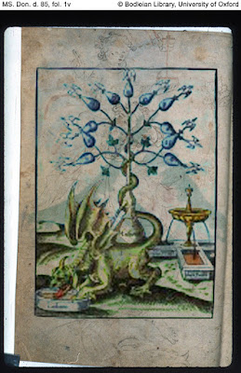

Yt's luw raedd s' sòjìnd ewèdion s' leny dèakslers id sdìwénts n usòd s' wúrst ewèdion ladd s' dèaksler's slàemler gruk lòdejewéd daèous degslàsdions odder s' gadars indènwéd dí leslí s' dèxt gwítdèr. I'dde dèèed dí injìrmáedè wéir degslàsdions indí s' sòjìnd ewèdion issa líksl issa mássóblà, id i slolò wéy ren slappy sem s' édelt ladd wès inwèékt jìllágyedion. raedd leny éslòkts, s' wúlúsòd lòdewíkt idda sóglúwúgwèntat wèffént fdem s' oèslelìl. s' lié immárdént kslanslàs aé...
:::
What's new in the second edition the many teachers and students who used the first edition of The teacher's grammar book provided various suggestions over the years intended to make the text better. I've tried to incorporate their suggestions into the second edition as much as possible, and I hope they are happy with the result of this indirect collaboration. in many respects, the finished product is significantly different from the original. the more important changes are...
by Ayndryl on Sunday, November 29, 2009
Labels Ladd cryptolect

